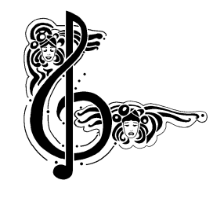i

***The North Port Chorale***

***Presents***

**Artistic Director**

**Paul D Webster Greene**

**Saturday Evening Performance**

**December 9, 2023 at 7:00 PM**

**Doors open at 6:30 PM**

**All Seats Reserved**

**Handicap Available on   
Main Floor ONLY**

**North Port Performing Arts Center**

**6400 W. Price Blvd, North Port, FL**

**For tickets or Information Call: 941-426-8479 or 1-800-406-7722**

**Visit our Website at www.NORTHPORTCHORALE.org  
or follow us on Facebook.**

HOME

FOR THE HOLIDAYS …The Sounds of The Season

**!!**